

GUIDANCE for

FIRE RISK ASSESSMENT Stage 2;
Termly Fire Inspection & Risk Assessment

To be used with the Fire Risk Assessment Stage 2
Quarterly Workplace Fire Inspection form and checklist

Introduction

To comply with the Regulatory Reform (Fire Safety) Order 2005, The Montessori Place must ensure that a suitable and sufficient fire risk assessment is carried out identifying the risks to which relevant persons are exposed and for the purpose of identifying the general fire precautions that are needed to ensure the safety of all children, staff, service users, contractors and visitors whilst on premises.

The Montessori Place has adopted a two-tier system of fire risk assessments to be implemented in all council buildings:
Stage 1: A fully comprehensive fire risk assessment for the premises
Stage 2: A termly workplace Fire Inspection & Risk Assessment to supplement the comprehensive fire risk assessment as above and ensure day-to-day management of fire safety.

Fire risk assessors’ duties

The fire risk assessor’s duties are to carry out regular visual checks and complete the termly workplace fire inspection and risk assessment for their work premise or work areas. They must report significant hazards to the Early Years Manager who also has day-to-day responsibility of the premises.

This guidance is intended to assist trained Fire Risk Assessors to carry out the quarterly workplace Fire Inspections for Stage 2.

Further information

For further information and details of the requirements of the Regulatory Reform (Fire Safety) Order please refer to the Fire Safety Policy.

GUIDANCE NOTES

How does fire start?

Firstly you need to understand the basic principles of how fire starts and spreads rapidly throughout a building.

For a fire to start, three things are needed:

- A source of ignition

- Fuel

- Oxygen

This is known as The Fire Triangle

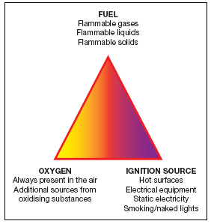

If any one of these is missing, a fire cannot start. Taking measures to avoid the three coming together will therefore reduce the chanced of a fire occurring.

How does fire spread?
Fire is spread by three methods:
- Convection – this is the most dangerous and causes the largest number of injuries and deaths. Hot smoke rises, gets trapped by the ceiling and then spreads in all directions, through any holes or gaps in the walls, ceiling and floor to other parts of the building. The heat from the fire gets trapped in the building and the temperature rises. The fire is fuelled by anything combustible and flammable as its spreads.
- Conduction - materials such as metal absorb the heat and can transmit it to other rooms where it can set fire to combustible items.
- Radiation – Heat may be transmitted in straight lines and heats the air the way an electric bar heater heats a room. Any paper or material close to the fire will absorb the heat until it starts to smoulder and burn.

Fire in a building generates smoke that contains toxic gases which are harmful. The smoke is thick and black, obscures vision and causes great difficulty in breathing leading to asphyxiation.
Never under-estimate the speed that smoke and fire can spread.

Fire risk assessment

A fire risk assessment is an organised and methodical look at the premises, the activities carried on there and the likelihood that a fire could start and cause harm to those in and around the premises.

Comprehensive Stage 1 fire risk assessment is undertaken by a competent person and will be reviewed by a competent person every approximately every 2 yrs depending on the risk and type of premise, or whenever there is a significant change.

Rob Gueterbock is responsible for managing the Stage 1 Fire Risk Assessment and Action Plan.

It is essential that fire safety is managed on a daily basis, partly through all staff being vigilant and fire safety aware of their environment and also through more formal procedures such as the quarterly fire inspection.

Therefore Rob Gueterbock, or a staff member nominated by him will carry out the Stage 2 quarterly fire inspection / risk assessment to look for fire hazards and to ensure they are either dealt with or reported to the The Director/Head of School or the Director/Early Years Manager, who have responsibility for the premises, to action.

This will ensure that fire safety is continually managed and that fire hazards do not go unnoticed and increase the risk of fire, in the time between the comprehensive reviews of the premise.

Prioritisation

The Action Plan needs to indicate the priority of the action that is required to be taken, taking into account the potential severity should a fire occur and how likely a fire might occur for each identified hazard or non-compliance with legislation.

 | Negligible Hazard | Slight Risk to Property | Moderate Risk to Property / Slight Risk to Life | Moderate Risk to Life | Severe Risk to Life
Unlikely to Occur | Low | Low | Medium | Medium | Medium
Possible | Low | Medium | Medium | Medium | High
Likely to Occur | Medium | Medium | High | High | High

Any items identified as presenting an imminent risk of danger must be dealt with immediately.

High | Action recommended within 1 month of the report
Medium | Action recommended within 3 months of the report
Low | Action recommended within 12 months of the report

Prioritisation is always going to be very subjective and it may be tempting to put everything as ‘High’ priority to err on the side of caution. However a reasonable amount of common sense must be used, remembering that not all remedial works can actually be done within a month due to reasons such as budget restrictions, ordering new parts or availability of contractors to undertake the works etc.

When actions are referred to the Directors they will again be prioritised, in the light of the action required for the building as a whole, and should be either completed or planned within the timescales given, as far as is reasonably practicable and progress recorded.

Where items have to be delayed for financial or programming reasons, other temporary controls may have to be put in place.

Examples of imminent risk:

A highly flammable substance near a source of ignition.
A gas leak – the pilot light could start a fire or turning on an electric light could cause an explosion.
Any ignition source near combustible items.
A curtain draped over a light bulb.
A coat pushed against an electric heater.
Exit doors locked with no key
Exposed wires on an electrical appliance or plug

Examples of High priority
Exit doors difficult to open
Combustible items piling up near an ignition or heat source.
Tea cloths left near / on a cooker
No emergency evacuation plan
No fire safety awareness or evacuation procedures given at Induction.
Damaged electrical equipment
Incorrect storage of flammable substances
Overloading of sockets
No directional signage in a large or complex building
Tripping hazard on stairs
No gas service within the last 12 months

Examples of Medium priority
Fire doors not closing properly
Damaged fire doors
Damaged emergency lighting
Incorrect signage (text instead of pictogram)
Build up of combustible materials
Extinguishers missed one inspection
No PAT testing where the equipment is fairly new

Examples of Low priority

Floor cable covers in place for over 6 months and being frequently walked on
Signage beginning to fade / wear
Incorrect positioning of fire extinguishers
An office appliance missed the last PAT test
Extra wall or floor sockets required (higher priority if there is dangerous overloading)
Low risk of arson

4. Using the Checklist

Firstly you need to identify all sources of ignition, fuel and oxygen that are present in the premises /area. Some of these are obvious and will be present in all areas, such as paper and fabrics, but in identifying them you will become more aware of their potential to spread the fire, especially if there is an excessive amount of storage, and become aware of the less obvious.

1. Identifying Sources of Ignition
You can identify the potential ignition sources in your premises by looking for naked flames and possible sources of heat which could get hot enough to ignite material found in your premises. These sources could include:
- Cigarettes, matches & lighters (are outdoor smoking areas too near cars or recycling / waste bins?)
- Naked Flames, e.g. candles, Bunsen burners, open flame equipment
- Electrical, gas or oil-fired heaters (fixed or portable)
- Hot processes, e.g. welding by contractors or shrink wrapping
- Cooking equipment
- Faulty or misused electrical equipment
- Lighting equipment, e.g. halogen lamps or display lighting too close to storage, or displays near wall lighting
- Hot surfaces and obstruction of equipment ventilation
- Arson
Look for indications of ‘near misses’ such as scorch marks on furniture or fittings, discoloured or charred electrical plugs and sockets, cigarette burns etc.

Arson

Fires started deliberately can be particularly dangerous because they generally develop much faster and may be intentionally started in escape routes.

Measures to reduce arson may include the following:

- Make sure you regularly remove all combustible rubbish

- Do not place rubbish skips adjacent to the building and secure waste bins in a compound separated from the building

- Do not park vehicles or store materials outside next to windows or doors that open into the building

- Encourage staff to report people acting suspiciously

- Secure flammable liquids so that intruders cannot use them

- Secure all storage areas and unused areas of the building that do not form part of an escape route against unauthorized access, ensure access to keys to those areas is restricted

- Fit secure metal letterboxes on the inside of letter flaps to contain any burning materials that may be pushed through

2. Identifying Sources of Fuel
Anything that burns is fuel for a fire. You need to assess how much combustible material there is in your workplace i.e. anything that will burn reasonably easily and are in enough quantity to provide fuel for a fire or cause it to spread to another fuel source. Some of the most common ‘fuels’ found are:
- Paper and card e.g. stationary, filing, packaging materials, advertising material and decorations
- Flammable-liquid-based products, such as paints, varnishes, thinners and adhesives
- Flammable liquids and solvents, such as cooking oils, white spirit, methylated spirit and disposable cigarette lighters
- Flammable chemicals, such as certain cleaning products, photocopier chemicals and dry cleaning that uses hydrocarbon solvents
- Plastics and rubber, such as video tapes, polyurethane foam-filled furniture and polystyrene-based display materials
- Textiles and soft furnishings, such as hanging curtains and clothing displays
- Waste products, particularly finely divided items such as shredded paper and wood shavings, off cuts and dust
- Flammable gases, such as liquefied petroleum gas (LPG), acetylene (N.B the Fire Brigade have to be notified if acetylene is stored on the premises)

3. Identifying Sources of Oxygen
The main source of oxygen for a fire is in the air around us. This generally falls into two categories: natural airflow through doors, windows and other openings or mechanical air conditioning systems and air handling systems. In many buildings there will be a combination of systems, which will be capable of introducing/extracting air to and from the building.
Additional sources of oxygen can sometimes be found in materials used or stored at premises such as:
- Some chemicals (oxidising materials), which can provide a fire with additional oxygen and so help it burn. These chemicals should be identified on their container by the manufacturer or supplier (shown below) who can advise as to their safe use and storage
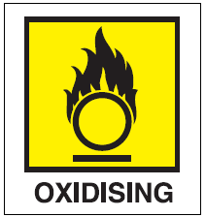
- Oxygen supplies from cylinder storage and piped systems, e.g. oxygen used for medical purposes or in welding processes (N.B the Fire Brigade have to be notified if oxygen is stored on the premises)

4. Electrical Hazards
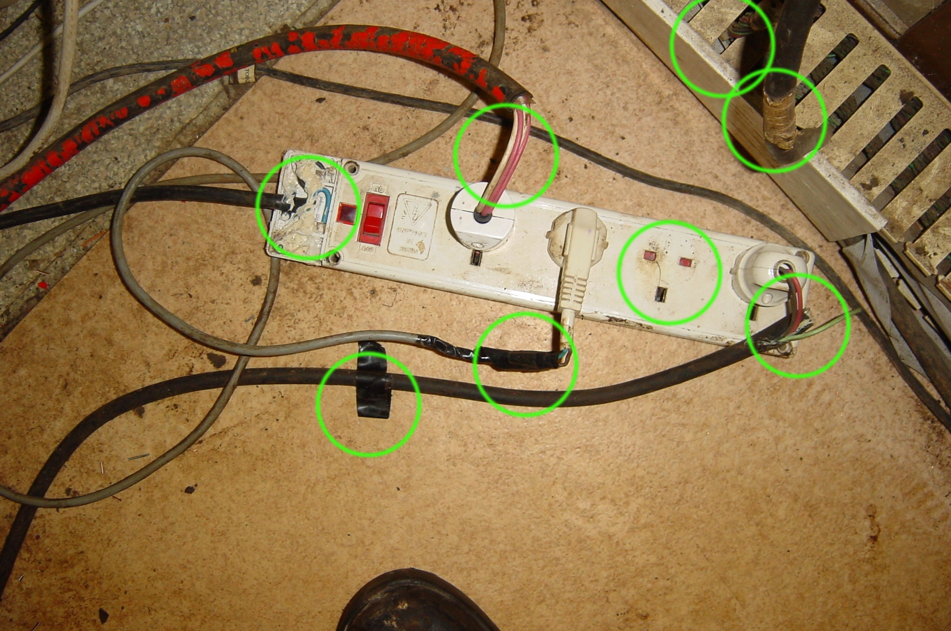

Electrical equipment can be a significant cause of accidental fires in buildings and needs to be regularly visually inspected as well as annual checks and servicing by a competent electrician.

Basically you need to take a quick look at the general condition of the electrical equipment in your premises / area e.g. computers, printers, kettles, heaters, cables, plugs and sockets. Is it all in good condition or is it broken, has scorch marks, frayed cables or exposed wires coming out of the plug?

The main hazards that can cause a fire are:

- Overheating cables and equipment, e.g. due to overloading circuits, bunched or coiled cables or impaired cooling fans

- Incorrect installation or use of equipment

- Damaged or inadequate insulation on cables or wiring

- Combustible materials being placed too close to electrical equipment which may give off heat even when operating normally or may become hot due to a fault

- Arcing (which causes intense heat), overheating and electrical leakage (even from very low voltage equipment) can cause fire or explosion by igniting flammable materials /substances.

- Overloading of sockets: No block adaptors may be used only bar adaptors. The total current, used by the appliances plugged into one adaptor, must not add up to more than 13 amps of current altogether. Computers and printers are usually 3 – 5 amps each and so can be used with an adaptor but a kettle is 13 amps so must not be plugged into an adaptor with other appliances.

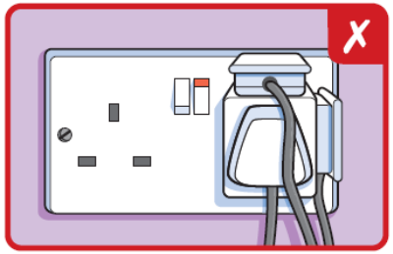

- Inadequate servicing and maintenance of equipment

- Overheating cables due to retention in a coil. Cables should not trail across floors; as well as causing a trip hazard, especially during an evacuation when visibility is poor, continuously walking over them (even under a cable cover) can cause them to wear and break in time and cause a fire.

All portable electrical equipment should be PAT tested at regular intervals. It is The Montessori Place policy is to PAT test all equipment annually – even though manufacturers often recommend longer intervals (e.g. 2-4 yrs) for some equipment. (It would be too complicated to work out all the different intervals of so much equipment.)

Evidence of PAT testing can be checked by looking for the label and date last tested. Look particularly for any equipment that is put away in cupboards and may have missed the annual check.

Staff may not bring in used electrical equipment from their home as the condition and safety of the item is unknown (e.g. whether it has been tampered with or repaired by an unqualified person).

Remove faulty or damaged equipment immediately (or unplug it and put a warning label on it) as someone could be electrocuted as well as cause a fire.

If you have any doubt about the safety of your electrical installation then you should consult a competent electrician.

5. Gas Safety
A competent person (Corgi registered) must carry out a service of any gas boiler or gas appliances annually and provide a certificate.
All combustible materials must be kept away from any gas-burning device.
The gas shut off valve should be in an accessible place.
If you have any doubt about the safety of your gas installation then you should consult a Corgi registered engineer / plumber.

6. Identifying People at Risk
You will need to identify those people who may be especially at risk such as:

- People working alone or in isolated areas (such as roof spaces or storerooms).
Can they hear the fire alarm, do they need assistance to evacuate, does anybody know they are there, do fire wardens check the area to see if they have evacuated, can they raise the alarm from those areas etc?

- Large numbers of people unfamiliar with the layout of the building e.g. public, contractors, visiting school children.
Is signage clear to show the directions for escape and exit, are staff on hand to assist with evacuation, are there fire wardens to do a sweep of the area? Remember that people do not always react immediately to a fire alarm so nominated staff may need to give instructions – is this procedure in place?

- People who cannot escape without assistance e.g. young children, babies, elderly people, disabled people (in particular people with mobility impairments).
Are there arrangements in place to evacuate all disabled people from the building, including staff, visitors or members of the public, are there trained staff to use Evac-chairs for mobility impaired people, or ‘buddies’ to assist others when required?
(Please refer to the Fire Safety Policy Guidance: Appendix A: Evacuation of Disabled Persons from Council Premises.)

- People who are not able to leave the premises quickly - but do not require assistance, e.g. people with temporary impairments (e.g. on crutches) parents with very young children etc

Are there staff available to assist elderly or infirm people from the building should it be necessary – it must be a robust procedure not an assumption that someone may offer to help.

Staff must assess the individual requirements of people with learning difficulties as to the level of assistance they may need to evacuate the building.

- Full details of PEEP’s are in the above mentioned Policy Guidance

- Pupils / students / young persons in unsupervised areas.
Procedures must be in place to ensure that they know what to do when the fire alarm sounds (through fire drills), backed up by nominated staff / fire wardens doing a sweep of the areas to ensure all such areas are cleared.

- People with language difficulties
If there are a significant number of non-English speaking people in the premises then the emergency evacuation procedures must be translated and explained to them either in written form or verbally (preferable both) and tested in drills to ensure they have understood.

7. Fire-Detection and Fire Warning Systems

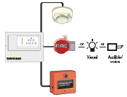

Fire Detection and Alarm Systems

There is a need to have effective systems in place to give warning in the event of a fire. British Standard 5839 part 1 L2 (1998), and the more recent BS EN 54 series, lay down the standards for fire detection and alarm systems including design considerations, installation and commissioning and user responsibilities. User responsibilities are summarised below.

A responsible person should be appointed to supervise the alarm system. S/he should ensure the system is maintained and serviced at the recommended intervals to ensure that it is capable of operating correctly.

Procedures should be laid down for dealing with alarm activation's, fault warnings or taking part or all of the system out of service.

The person responsible for the alarm system should:

- Ensure that authorised persons are instructed in its proper use, the correct interpretation of the indicators and their relationship with the building layout
- Establish liaison with those responsible for building maintenance to ensure that their work does not cause faults on, or otherwise interfere with the operation of, the fire alarm system
- Ensure any necessary changes to the fire alarm system are considered at an early stage if there are plans to make structural or occupancy changes to the buildings
- Ensure that a clear space is preserved in all directions below every detector and that all manual call points remain unobstructed and conspicuous

Drawings showing the position of detectors and alarm equipment, wiring diagrams, circuit diagrams and operating instructions should be kept up to date and easily available.

An alarm system logbook should be maintained that includes:

- The name of the responsible person
- Brief details of servicing arrangements
- Dates and times of all alarm activation's
- Dates, times and types of all defects and faults
- Dates and types of all tests
- Dates and types of all servicing
- Dates and times of all periods of disconnection or disablement
- All alterations to the system

Prevention of False Alarms

Many false alarms are caused by operations in the vicinity of the detectors carried out either negligently or in ignorance. The person responsible for the alarm system should ensure that all staff and visiting contractors are aware that the building is fitted with an automatic fire detection system.

Where temporary work involving the generation of dust, smoke, paint spray, etc. is to be carried out in areas protected by smoke detectors, precautions should be undertaken to prevent false alarms and damage to the detectors. Suitable measures include:

- Temporary replacement of smoke detectors with heat detectors
- Provision of a screen between the work and the detector
- Provision of temporary covers such as plastic or paper bags

As the sensitivity of the alarm system will be impaired by these actions, and the risk of fire is higher during periods of construction or maintenance, staff and contractors should be particularly vigilant during these times. Once the work is completed the person responsible for the alarms must ensure the detectors are correctly reinstated and check the system for correct operation.

Maintenance and Servicing of Alarm Systems

To ensure the fire alarm system is reliable, correct servicing is essential. Normally a service agreement should be made with the manufacturer, supplier or other competent contractor. The name and telephone number of the alarm-servicing contractor should be prominently displayed at the control and indicating equipment. For residential premises, e.g. boarding houses, dormitories, study/bedrooms, etc, an engineer should be on call at all times, both during and outside normal working hours.

On a daily basis:

- The panel should be checked to ensure it is operating normally or if a fault is indicated that this is recorded in the logbook and appropriate action is taken.

On a weekly basis;

- At least one detector, call point or end of line switch on one zone should be operated to test the ability of the control and indicating equipment to receive a signals and sound the alarm. For systems having 13 zones or less, each zone should be tested in turn; if there are more than 13 zones then more than one zone may need to be tested in any week so that the interval between tests on one zone does not exceed 13 weeks. It is preferable that each time a particular zone is tested a different trigger device is used. This test should be recorded.
- If any batteries are open and accessible, then a visual examination of the battery and its connections should be made to ensure that they are in good condition. Action should be taken to remedy any defects, e.g. low electrolyte levels.

Every 3 months ensure that:

- Any necessary action has been taken for entries in the alarm system log book
- Batteries and their connections are examined and tested as specified by the supplier
- Batteries are tested to indicate they are satisfactory for a further 3 months by taking measurements such as voltage on a known and very high rate of discharge
- The alarm sounders and any link to a remote manned centre, other than a 999 auto-dialler, operate correctly
- All ancillary functions of the control panel work correctly. Fault indicators and their circuits should ideally be tested by simulation of fault conditions
- There is no sign of moisture ingress or other deterioration in the control and indicating equipment
- There has been no structural or occupancy changes which mean that manual call points, detectors or sounders need to be relocated

On an annual basis:

- Check each detector for correct operation in accordance with the manufacturer's recommendations
- Make a visual inspection to ensure that all cable fittings and equipment are secure, undamaged and adequately protected

Action after a fire:

- Each detector, call point and alarm sounder that may have been affected by the fire should be tested
- All other parts of the fire alarm system which may have been affected by the fire, e.g. wiring and power supplies, should be examined for signs of damage
- Any defects found should be recorded in the log book and repairs arranged
- The alarm servicing contractor should check the system

Action after a false alarm:

- Identify the particular detector or call point that initiated the alarm
- If possible establish the cause of the alarm
- Record in the log book and inform the servicing contractor
- If one detector or a group of detectors gives repeated false alarms, the alarm servicing contractor should be asked to investigate. The average rate of false alarms from an installation should not exceed one false alarm per year for each 10 detectors connected to the system. The number of false alarms for an individual detector should not exceed one false alarm per 2 years.

Action following identification of an alarm system fault:

- Identify the area affected and decide if special action, e.g. fire patrols, are needed in the area
- Determine the reason for the fault, or note the activities in the area immediately prior to the fault
- Record in the log book and arrange for repair

Maintenance of Detectors

The sensitivity of detectors is adversely affected by the rapid accumulation of dirt. Routine tests are therefore essential to ensure that detectors maintain the requisite degree of sensitivity to fire.

Heat detectors should be visually examined for damage or other conditions, e.g. a coat of paint, likely to interfere with correct operation. 2% of the installed heat detectors should be operated annually by the application of a heat source as a check on reliability. Different detectors should be tested each year.

Other types of detectors should be checked in accordance with the manufacturer's recommendations.

8. Fire Extinguishers

All new fire extinguishers are coloured red. However, they still have a small panel indicating the former British colour-coding.

Colour Contents For Use On:
of panel
Red Water Multi-purpose (not electrical) wood, paper, fabric
Black CO2 Electrical equipment
Blue Powder Flammable liquids, petrol, electrical, wood
Cream Foam Oil and fat (not electrical)
Cream Aqueous foam Multi-purpose (not electrical)

All fire extinguishers must placed in the correct position, signed, be in satisfactory working order, checked weekly and tested annually by a competent person.

Fire extinguishers must be positioned in every building whether or not staff are trained to use them.

If there is a danger that the extinguishers could be used as a weapon e.g. by people under the influence of drugs or alcohol, or by those with challenging behaviour, or if they are repeatedly set off e.g. in schools, then they may be locked in a cabinet designed for the purpose, with either a padlock, break glass key or siren alarm fitted.

Only staff who have had specific training may use a fire extinguisher or other fire fighting equipment and only then if the fire is the size of a waste paper bin and if they are not putting themselves at risk.

Using a fire extinguisher incorrectly can result in serious injury and make the fire spread more rapidly. Using the wrong type of extinguisher can even lead to a fatality e.g. if water is sprayed onto a fire started by an electrical fault or hot cooking oil etc.

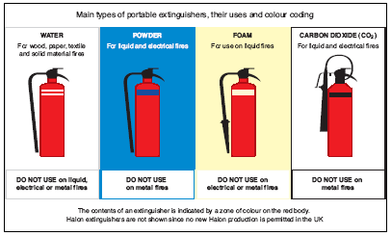

9. Escape Routes

Escape routes should be designed to ensure, as far as possible, that any person confronted by fire anywhere in the building should be able to turn away from it and escape to a place of reasonable safety, e.g. protected corridors subdivided with fire doors or a protected stairway, which lead to a place of total safety outside and away from the building

In general there should normally be at least two escape routes from all parts of the premises but a single escape route may be acceptable in some circumstances (e.g. from rooms / areas accommodating less than 60 people or where there are short travel distances to a place of safety).

Holes or gaps in ceilings and floors will allow hot smoke to spread the fire more quickly to other parts of the building, so must be filled with a fire retardant foam.

It is essential to maintain sufficient protection in corridors and stairways i.e. escape routes, to give people time to escape. Therefore they must be kept clear at all times of:

- obstructions e.g. furniture, filing cabinets, storage.

- 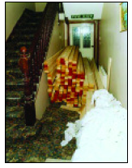

- slipping / tripping hazards e.g. trailing cables, loose /worn carpet, leaves and algae on external fire escapes, spillages / wet floors must be signed with a hazard warning cone /sign immediately etc

- items that may be a source of fuel e.g. boxes, recycling paper, fabric covered chairs etc

- electrical items or other ignition risk e.g. such as photocopiers, heaters etc

- notice boards and display materials – these must be kept to an absolute minimum and preferably in fire retardant display cases or displays treated with a flame-retardant spray.

Inner rooms

Where the only way out of a room is through another room, an unnoticed fire in the outer room could trap people in the inner room. Adequate warning of a fire should be provided by any one of the following means:

- A vision panel between the two rooms

- A large enough gap between the dividing wall and the ceiling, e.g. 500mm, so that smoke will be seen

- An automatic smoke detector in the outer room that will sound a warning in the inner room

10. Doors

Correctly specified and well-fitted doors will hold back fire and smoke preventing escape routes becoming unusable, as well as preventing the fire spreading from one area to another.

All fire-resisting doors, other than those to locked cupboards and service ducts should be fitted with an appropriately controlled self-closing device that will effectively close the door from any angle.

Test the door closer by holding the door open and letting go. Does it close slowly enough to avoid injury and does it close fully?

Fire doors must never be wedged open as this can cause the door to warp and so will not hold back fire and smoke. Also they can be left open during an evacuation causing smoke and fire to spread to the protected escape routes and stairways. If fire doors are required to be kept open, then they must be fitted with an automatic door hold open /release device that releases the door when the fire alarm sounds. These devices should be routinely tested i.e. when the alarm is tested weekly.

Exit doors on escape routes and final exit doors should normally open in the direction of travel, and must be quickly and easily opened without the need for a key (keys in a break-glass device are acceptable if already in place but should not be purchased new as they are not the most suitable device).

Security is a major factor for the majority of council premises and there are a number of security devices for final exit doors, such as push-bars, that allow the door to be easily opened from the inside but not the outside. Any more complex devices must also be easily opened in an emergency by anyone e.g. not just trained staff, but any visitor, cleaner or contractor who might find themselves trapped if staff are not present. For example such devices can be linked to the fire alarm so that it is released when the alarm sounds.

11. Stairways

Stairways, if unprotected from fire, can rapidly become affected by heat and smoke, cutting off the escape route and allowing fire spread to other floors. However, if adequately protected, escape stairways can be regarded as places of reasonable safety to enable people to escape to a place of total safety.

*As stated under Escape Routes - although the common ways in civic buildings are the responsibility of the Premises Manager, fire risk assessors should also carry out a general check and report any hazards to the premises manager.

Stairways must be kept completely free of notice boards and display materials. Only Safety signs (e.g. Fire notices) may be put on the landings.

No storage may be kept under stairs.

An external stairway should have non-slip treads and must be regularly maintained as the treads may become slippery, e.g. due to leaves, algae, moss or ice.

Residents or members of the public should not normally use external stairways.

12. Emergency Escape Lighting

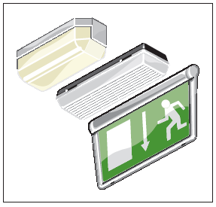

Fire can quickly affect the electrical installation in a building and so normal lighting can fail. Therefore escape routes need to be adequately lit so that people are not plunged into darkness when trying to escape.

The Stage 1 risk assessment will involve a check on the positioning and adequacy of the emergency lighting.

The Stage 2 check is a general check that all escape routes, i.e. corridors and stairways have adequate lighting for the general safety of people using the building and during practice fire drills. Also to check the condition of the luminaries and to report any that are broken or dirty.

All emergency escape lighting systems should be regularly tested and most existing systems will need to be manually tested monthly - usually by using a ‘fishtail’ key inserted into a special switch on the wall, to ensure that each emergency lamp illuminates.

A record must be kept of the tests.

13. Signs and Notices

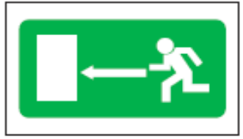

Signs must be pictographic, as above, to comply with the Health & Safety (Safety Signs and Signals) Regulations 1996. The pictograms may contain text but must not be text only.

Signs on escape routes should incorporate a directional arrow. Arrows should not be used on their own.

Signs should be positioned so that a person escaping can always see the next escape route sign.

A number of other mandatory signs such as ‘Fire action’ notices are also necessary. These should be positioned on escape routes adjacent to fire break-glass call points and where staff or the public frequently assemble in the premises, e.g. the staff rooms, canteens, foyers /reception areas, locker rooms etc.

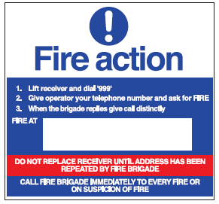

Where Evac-chairs are installed there should be a sign on each floor to indicate the names and phone numbers of the trained Evac-chair buddies.

15. Emergency Evacuation Plans

Each premises must have a revised Emergency Evacuation Plan to comply with the Regulatory Reform Fire Safety Order. Premises managers are responsible for preparing the Plan and a template has been designed and has been put on the Wave to assist premises managers. All members of staff need to read the plans.

You will need to ask various members of staff in your premise /area whether they have seen the new Plan, including new and temporary /agency staff.

16. Information, Instruction & Training

All persons visiting or using a building must be given clear and appropriate as to what they should do if there is a fire.

For example the employers of contractors and cleaners should be given a copy of the Emergency Evacuation Plan so that they can inform their employees.

Managers should ensure that new staff and temporary staff are instructed in the procedures on their first day.

Visitors should be either escorted all the time they are in the building or given instructions as to what to do if there is a fire.

Staff need to know the policy for the use of fire extinguishers i.e. not to use them unless they have been trained. (Full details are in the Fire Safety Policy Guidance.)

Managers who manage teams are responsible for nominating staff to undertake specific responsibilities for fire safety e.g. fire wardens, the fire risk assessor, 1st Aiders, Evac chair buddies etc to ensure the safety of their staff. This can be a shared resource in large buildings or for small teams.

17. Any Other Hazards

Please use this section to add any further hazards or risks that you might notice that have not been covered already.

