BASIC FIRE SAFETY

Information Staff should be aware of:

- Discovering a fire – Personnel should be aware of the method of raising the alarm in a premises, this should include the position of manual fire alarm call points and their method of operation.
- Hearing the fire alarm – Personnel should be aware of the evacuation procedures in their premises. They should know escape routes and final exits, they should also be aware of fire doors and their purpose in protecting escape routes.
- Assembly points – Personnel should know their ‘Fire Assembly Point’ and aware of the need to ensure everybody have been accounted for.
- Calling the Fire and Rescue Service – Personnel should be aware of the method of calling the fire service and the location of telephones.
- A basic knowledge of the theory of fire – The fire triangle
- Use of fire extinguishers – Personnel should be trained in the safe use of fire extinguishers.

The Fire Tetrahedron

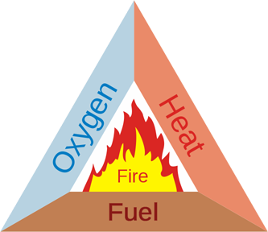
For many years the concept of fire was symbolized by the Triangle of Combustion and represented, fuel, heat, and oxygen. Further fire research determined that a fourth element, a chemical chain reaction, was a necessary component of fire. The fire triangle was changed to a fire tetrahedron to reflect this fourth element. A tetrahedron can be described as a pyramid which is a solid having four plane faces.

Essentially all four elements must be present for fire to occur, fuel, heat, oxygen, and a chemical chain reaction. Removal of any one of these essential elements will result in the fire being extinguished.

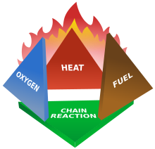
The four elements are oxygen to sustain combustion, sufficient heat to raise the material to its ignition temperature, fuel or combustible material and subsequently an exothermic chemical chain reaction in the material. Each of the four sides of the fire tetrahedron symbolise the Fuel, Heat, Oxygen and Chemical Chain Reaction. Theoretically, fire extinguishers put out fire by taking away one or more elements of the fire tetrahedron.

The symbol although simplistic, is a good analogy, how to theoretically extinguish a fire, by creating a barrier using foam for instance and prevent oxygen getting to the fire. By applying water you can lower the temperature below the ignition temperature or in a flammable liquid fire by removing or diverting the fuel. Finally interfering with the chemical chain reaction by mopping up the free radicals in the chemical reaction using, BCF and other halon extinguishers, it also creates an inert gas barrier. However this type of extinguisher is being phased out and in the future other extinguishing agents may be found using this principle.

Portable fire extinguishers

What should you do if you discover a fire? You must get everyone out as quickly as possible and call the fire brigade. However you may discover a fire in its very early stages and successfully use a fire extinguisher. The first thing that you should remember, however, is that fire spreads very quickly. Even a small, contained fire can quickly spread, producing smoke and fumes which can kill in seconds. If you are in any doubt do not tackle the fire, no matter how small. You can put yourself at risk by fighting the fire. If in doubt, get out, call the Fire Service out and stay out.

Fires are classified in four groups A, B, C, and D
- Class A fires – are fires involving organic solids like paper, wood, etc
- Class B fires – are fires involving flammable Liquids.
- Class C fires – are fires involving flammable Gasses
- Class D fires - are fires involving Metals

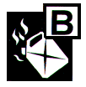

Electrical fires are not included, as they can fall into any of the classifications. However if you use a standard water extinguisher you must isolate the electric supply first as you could be electrocuted. Water based extinguishers such as foam and water mist are safe for use on electrical fires if they have been tested to 35000V (also written 35kV) and a safety distance of 1m is adhered to. In addition it must be remembered that certain electrical apparatus maintain a lethal charge for some time after they have been switched off.

