Purpose of this document
The purpose of this document is to set out how the Montessori curriculum to age 16 is being implemented at the level of Schemes of Work.
The document is structured as follows:
- How a Montessori Adolescent Community functions
  - Mixed age community
  - Lesson structure
  - Uninterrupted work cycle
  - Observation and planning
  - Formative and summative assessment
- Sample Montessori Mathematics Lesson
- Sample Montessori English Lesson

How a Montessori Adolescent Community functions
Mixed-age community
Montessori classrooms are mixed-age communities. In our primary school programme, we have 30 children across the age ranges of 6-12 together in the same classroom. In the secondary school programme, we will have 25-30 adolescents aged 12-15 together, and 25-30 adolescents aged 15-18 together.
In 2016/17 we will have approximately 8 adolescents aged between 11 and 14. This number will grow by approximately 8 each year, for a total capacity of around 50 students at secondary school age.
Lesson structure
Lessons are given to individuals or small groups (2-3 individuals). It is rarely the case that a lesson is given to more than 5 children at a time. Lessons are given as children are ready for them, and they are tailored to the needs of the individual or the small group. Usually (though not always) there is follow-on work.
Lessons are as short as 5 minutes, and on occasion as long as 20 minutes. Seminars and classroom discussions are longer, sometimes over an hour long. Lessons are typically structured as demonstrations that invite subsequent student activity. For instance there may be a long lesson on Ratio and Proportion with 2 students at one table, while at the next table a Guide is giving a shorter lesson to a student on the metals in the periodic table, and shortly after a mixed-age group of students are shown the difference between a haiku and a senryu.
At the end of a lesson, the students continue to explore the concept presented. This exploration typically takes place over extended periods of time – sometimes an hour, often a number of days. The form of exploration varies: hands-on activity with a material, Internet research, or conversations with peers. Usually, though not always, the exploration ends with a ‘product’ e.g. a report or a model, which is then presented to the adult (called Guides) for assessment.
Work cycle
The Montessori approach is characterised by “work cycles” rather than subject periods. Students work on an area of interest for an extended period of time. New lessons are offered as students are ready for it, or as their engagement in their current activity wanes. Often students request a lesson in a particular area e.g. nuclear fission. Any student is welcome to join any lesson.
At any given moment the community of 25-30 students is working on a range of activities across the subject areas, with Guides giving lessons to different individuals or small groups at different times. When Guides are not giving lessons they are available to meet students, or are preparing for later lessons.
Observation and planning
Each student has their own individual learning journey. Planning for each student takes place in 6-weekly cycles, based on observation and assessment. Guides come together each week to discuss students’ work in individual subject areas and plan for lessons to offer each student in the subsequent 6-week cycle. Lessons are selected based on student’s interest and engagement and represent the next level of challenge in the work they are doing.
Formative and summative assessment
Lessons are offered to individuals or small groups (2-3 students) and this allows for continuous assessment. Lessons have prerequisites; the first stage of any lesson is to establish whether or not the prerequisite has been met. If it has not, the lesson is adapted to teach the prerequisite.
Evaluation of students work (written or presented) at the end of a concept set forms the basis of summative assessments. For example:
- Book review series
- Board game on the French Revolution
- Formula booklet for Newton’s Laws of Motion
For example, the Mathematics curriculum is constructed as a series of several hundred lessons. These lessons are typically brief (5-20 minutes), often involve hands-on manipulation, and offer opportunities for the student or students to start working with the concept. The adult checks that the student has a good grasp of the pre-requisites for the lesson at the start of that lesson. The lesson proceeds if the student does show that grasp. If not, the student is invited to revisit a concept that they need more time with, typically through a lesson.
The journey that any student takes through this set of several hundred lessons is individual to them. The rate at which they move through lessons is also individual to that student. They are continually assessed and lessons offered and re-offered to help them acquire concepts they have not yet shown mastery over.

Sample Montessori Mathematics Lesson (Parallel & Perpendicular Lines)
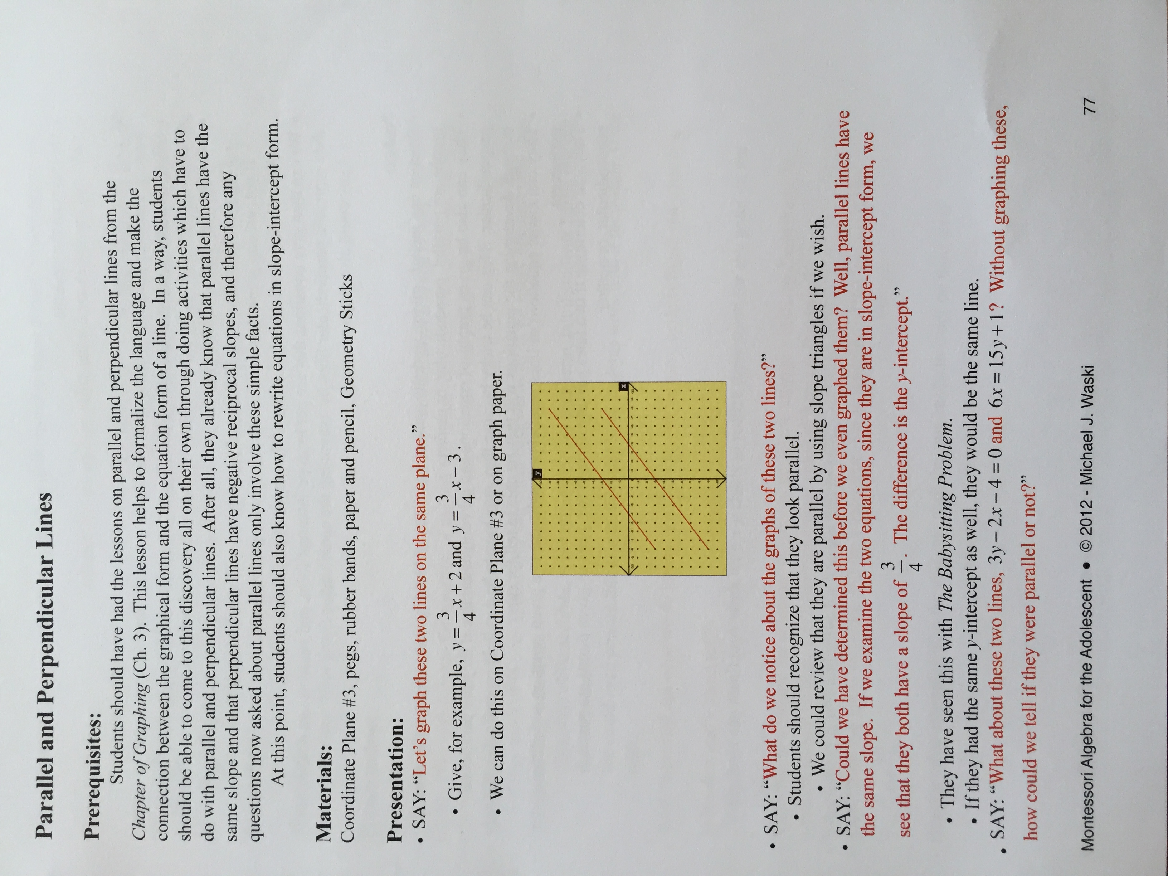

Sample Montessori English Lesson (Language: Rule of Concrete Details)
